Section 13.1: Comparing Three or More Means (One-Way Analysis of Variance)

Objectives: Students will be able to:
Verify the requirements to perform a one-way ANOVA
Test a claim regarding three or more means using one way ANOVA

Vocabulary:
ANOVA – Analysis of Variance: inferential method that is used to test the equality of three or more population means.
Robust – small departures from the requirement of normality will not significantly affect the results
Mean squares – is an average of the squared values (for example variance is a mean square)
MST – mean square due to the treatment
MSE – mean square due to error
F-statistic – ration of two mean squares

Key Concepts:

Requirements for a One-Way ANOVA test
- There are k simple random samples from k populations
- The k samples are independent of each other; that is, the subjects in one group cannot be related in any way to subjects in a second group
- The populations are normally distributed
- The populations have the same variance; that is, each treatment group has a population variance σ²
Verifying the Requirement of Equal Population Variances:
largest sample standard deviation is no more than two times larger than the smallest

One-Way ANOVA methods are robust
Decision Rule in the One-Way ANOVA Test:
If the P-value is less than the level of significance, α, then reject the null hypothesis
Instructions how to use the TI-83 and Excel to help us are given on page 691

Homework: pg 685-691; 1-4, 6, 7, 11, 13, 14, 19
Section 13.2: Post Hoc Tests on One-Way ANOVA

Objectives: Students will be able to:
Perform the Tukey Test

Vocabulary:
Post Hoc – Latin for after this
Multiple comparison methods – to determine which means differ significantly
Studentized Range Distribution – q-test statistic distribution (Table 8)
Experiment-wise error rate – also known as the family-wise error rate is also called the level of significance, α
Comparison-wise error rate – is the probability of making a Type I error when comparing two means

Key Concepts:
Requirements for testing Tukey’s test
After rejecting H₀: u₁ = u₂ = u₃ … = u_{k}
- k simple random samples from k populations
- k samples are independent from each other
- populations are normally distributed
- Populations have the same variance

Relationship between family-wise error rate, α, and comparison-wise error rate, α_{c}

1- α = (1 – α_{c})^{k}

Homework: pg 696 – 699: 1, 2, 3, 5, 6, 15, 18
Section 13.3: Randomized Complete Block Design

Objectives: Students will be able to:
Conduct analysis of variance on the randomized complete block design
Perform the Tukey test

Vocabulary:
factor – a level manipulated or set at different levels for a designed experiment

Key Concepts:

Three ways researchers deal with factors
- Control their levels so they remain fixed throughout the experiment
- Manipulate or set them at fixed levels
- Randomize so that any effects not identified or uncontrollable are minimized

Randomized Block Designs
- The Randomized Complete Block Design is a method for assigning subjects to treatments that can further reduce experimental error
- The subjects should be assigned in blocks
  - A block could be a car (assigning 4 tires)
  - A block could be twins (assigning 2 treatments)
  - A block could be schools (assigning 3 math tests)
- Blocks are homogeneous
- Every treatment is applied to every block
  - For each treatment, at least one subject in each block receives that treatment
- Within each block, treatments are assigned to the subjects in a random way
- There are designs that are even fancier, that further balances the design, such as Latin Square designs

Requirements for Analyzing Data from a Randomized Complete Block Design
The response variable for each of the k populations
- is normally distributed
- has the same variance
Note: design your experiment so that the sample size for each factor is the same, because analysis of variance is not affected too much when we have equal sample sizes even if there is inequality in the variances

Tukey Critical Value:
q_{α,v,k}

- The parameter α is the significance level, as usual
- The parameter ν is equal to (r – 1)(c – 1) where r is the number of rows (blocks) and c is the number of columns (treatments)
- The parameter k is the number of populations

Instructions how to use the MINITAB only are given on page 711

Example: Effect of diet on rats: Each block is a set of 4 newborn rats from the same mother. 5 sets of rats (5 blocks) are chosen for the experiment. The diets are randomly assigned -- the 4 diets to the 4 rats. Average weight gain (in ounces) is recorded for each block and is shown in the table below

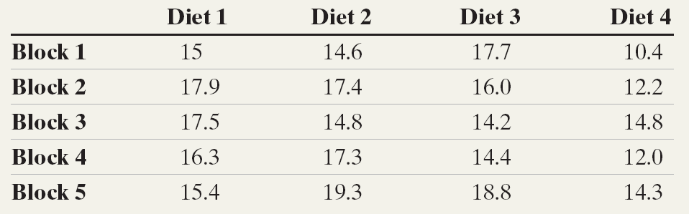

Excel Output

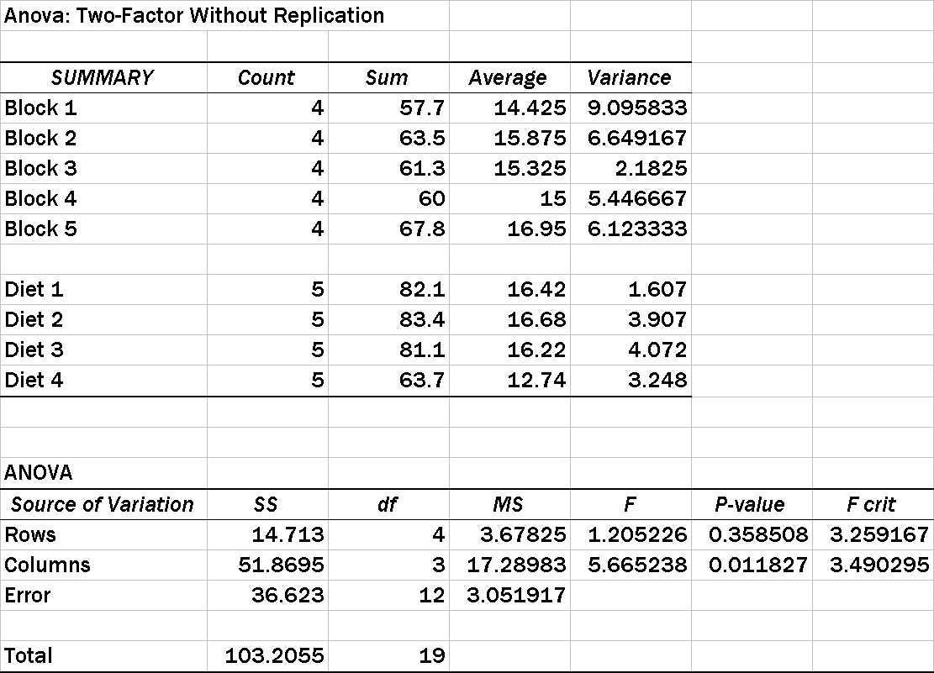

- Is there a difference between the litters?

- Is there a difference between the diets?

- Which diet is different?

Homework: pg 707 - 710: 1 – 7, 10, 15
Section 13.4: Two-Way ANOVA

Objectives: Students will be able to:
Analyze a two-way ANOVA design
Draw interaction plots
Perform the Tukey test

Vocabulary:
Factorial design – a design of experiment that will test n levels of k factors in a n x k factorial design
Cells – in a factorial design, a cell contains different levels of the factors
Crossed – a condition when all levels of one factor are combined with all levels of another factor
Main effect – the effect of changing levels of a single factor
Interaction effect – when changes in level of one factor result in different changes in the response variable for different levels of the second factor
Interaction Plots – graphical depictions of the interaction between factors in a factorial design

Key Concepts:
Requirements for the Two-way Analysis of Variance (ANOVA)
- The populations from which the samples are drawn must be normally distributed
- The samples are independent
- The populations have the same variance

Always test the hypothesis regarding the interaction effect. If the null hypothesis of no interaction is rejected, we do not interpret the results of the hypotheses involving the main effects because the interaction clouds those results.

Constructing Interaction Plots
- Compute the mean value of the response variable within each cell
- Compute the row mean value of the response variable and the column mean value of the response variable with each level of each factor
- On a Cartesian plane, label the horizontal axis for each level of factor A
Vertical axis will represent the mean value of the response variable
- For each level of factor A, plot the mean value of the response variable for each level of factor B
- Connect the points with straight lines (you should have as many lines as you have levels of factor B)
The more the difference there is in the slope of the two lines, the stronger the evidence of interaction

Instructions how to use the MINITAB only are given on page 727
Example 1: 3 patients in each age group are given each of the 3 different medications
The measured effects are

 |  | Age group
 |  | 21 – 30 | 31 – 40 | 41 – 50 | 51 – 60
Med | A | 2, 6, 3 | 5, 9, 1 | 4, 8, 8 | 6, 10, 9
Med | B | 1, 3, 2 | 2, 8, 3 | 5, 2, 3 | 6, 1, 1
Med | C | 1, 1, 4 | 6, 4, 8 | 7, 2, 5 | 4, 2, 8

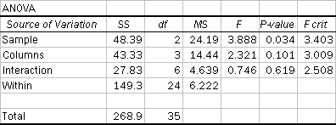

- Is there any interaction between age and the medication?

- Does the medication have an effect?

- Does age have an effect”

- Draw the interaction plot

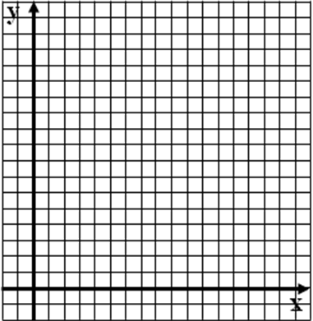

Homework: pg 723 - 727: 1-8, 10, 11, 17
Chapter 13: Review

Objectives: Students will be able to:
Summarize the chapter
Define the vocabulary used
Complete all objectives
Successfully answer any of the review exercises

Review Questions:

Example 1: When we are analyzing three or more means, we should use the technique of
  - The analysis of variance
  - Tests of dependent means
  - Tests of categories
  - The normal distribution

Example 2: Which probability distribution do we use when we want to test three or more means?
  - The normal distribution
  - The chi-square distribution
  - The t-distribution
  - The F distribution

Example 3: If an ANOVA has rejected the null hypothesis, then we could
  - Determine which of the means are significantly different
  - Conclude that the groups have the same population means
  - Collect more data until we do not reject the null hypothesis
  - All of the above

Example 4: The test used to determine which means are different, after performing an ANOVA, is the
  - Tukey More or Less Significant Test
  - Pearson chi-square test
  - Tukey Honestly Significant Difference Test
  - Pearson significant category test

Example 5: A randomized block design
  - Is a sampling method to ensure random samples
  - Is an experimental design that balances observations over the factors
  - Is a significance test of whether observed data has a normal distribution
  - Is a method to compute confidence intervals for the difference of three means

Example 6: In a randomized block design, if the null hypothesis of equal population means is rejected, then
  - We cannot determine which means differ significantly
  - We must reblock the design to collect factors
  - We could determine which means differ significantly by using the Tukey test
  - We should switch the blocks and treatments and analyze the data again

Example 7: To analyze mean responses correlated with the two factors “Gender” and “Age”, it would be appropriate to use
  - A chi-square test
  - A two-way analysis of variance
  - A normal z-score
  - A histogram

Example 8: Rejecting the null hypothesis that there is no effect of factor A on the response variable means that
  - Factor B must have an effect on the response variable
  - Factors A and B must have an interaction
  - The values of the response variable are independent of the levels of factor A
  - None of the above

Homework: pg 729 – 733; 3, 7, 10

